MTL Director Profile: Anthony Bow

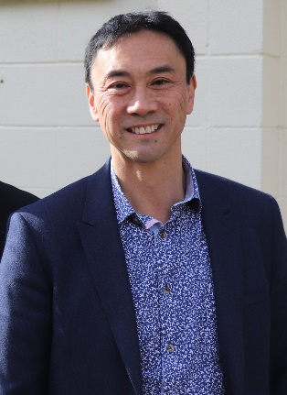
Anthony is Principal of Waimana Capital a strategy and expansion capital firm. He also holds governance roles as an independent director of Medical Sciences Secretariat Limited, independent director of Whai Rawa Fund Limited, member of the Medical Radiation Technologists Board and Chair & Trustee of Bill McKinlay Park Trust. Prior to this Anthony had financial services and taxation careers in the private and public sector. He has a BCom from the University of Auckland and holds Chartered Accountant from the New Zealand and Singapore professional accounting bodies.

https://www.linkedin.com/in/anthony-bow-3584972/

